Library Management System

Requirements Analysis

Prepared by,

Mohsin Ali

Muhammad Amir

Muhammad Taneer Khan

Junaid Ali

Asad Ur Rehman

Date Created: 5-9-2018

Table of Contents

1. Introduction 3

1.1 Purpose Of This Document 3

1.2 How To Use This Document 3

1.3 Scope Of The Product 4

1.4 Overview Of The Requirements Document 4

2. General Description 4

2.1 Product Perspective 4

2.2 Product Functions 5

2.3 User Characteristics 5

2.4 General Constraints 5

2.5 Assumptions and dependencies 5

3. Specific Requirements 6

3.1 Functional Requirements 6

3.2 Non-Functional Requirements 6

3.3 Interface Requirements 7

3.4 Licensing Requirements 11

4. References 11

**LIBRARY MANAGEMENT SYSTEM**

1. Introduction

1.1 Purpose of This Document

This is the Software Requirements Specification (SRS) for the LMS (Library Management System). The purpose of this document is to convey Information about the application's requirements, both functional and nonfunctional, to the reader. This document provides:

* A description of the environment in which the application is expected to operate.
* A definition of the application's capabilities.
* A specification of the application's functional and nonfunctional requirements.

The document is intended to serve several groups of audiences:

* First, it is anticipated that the SRS will be used by the **application designers.** Designers will use the information recorded here as thebasis for creating the application's design.
* Second, the **client** for the project, the library manager in our case, is expected to review this document. The SRS will serve to establish a basis for agreement between the client and development team about the functionality to be provided by the application.
* Third, the **application maintainers** will review the document to clarity their understanding of what the application does.

1.2 How to Use This Document

**Types of Reader**

* Stakeholders
* Developers
* Designers
* Testers

**Technical Background Required**

For software requirement analysis document there is no need of technical background.

1.3 Scope of the Product

The purpose of this software development project is to create a new application called: LMS SYSTEM. The Library Management System will be PC-based application, allowing library staff to search for books and library staff members to manage the book inventory and user database. The application will provide the following capabilities:

* Library staff will be able to manage library user accounts including remove, change, and add.
* Library staff will be able to manage the book inventory database including remove, change, and add.
* The application will provide search function of books based Book name or category.

The project's client has determined that this application will provide the following benefits:

* Provide additional flexibility and convenience to the library staff.
* Provide better reliability and security of the library information.
* Provide a more productive environment for the library staff member.
* Reduce the cost of the library operations.
  1. Overview of the Requirements Document

The rest of the SRS examines the specifications of the Library Management System in detail. Section 2 of the SRS presents the general factors that affect the LMS and its requirements, such as user characteristics and general constraints. Section 3 outlines the detailed, specific functional requirement, non-functional requirement and other related requirements.

2. General Description

2.1 Product Perspective

Library Management System is a Windows based application. LMS is used by library staff which is responsible to register a student and perform operations i.e. issue/search books, return books and many more. By LMS System the data of library is stored in database which can be manipulated by library manager and easy to access.

2.2 Product Functions

Functionality of this is

**LIBRARIAN:**

* A librarian can issue a book to the student.
* Can view the List of books available in each category.
* Can take the book returned from students.
* Add books and their information of the books to the database.
* Edit the information of the existing books.
* Can access all the accounts of the students.

2.3 User Characteristics

The two types of user for the LMS System are:

* **Library Manager:**
* Good understanding to library operation
* Responsible for library operation as a whole.
* Responsible for library staff managing
* **Librarian:**
* Good understanding to library operation
* Responsible for library operation.

2.4 General Constraints

LMS System can potentially have more users. So, it is unrealistic to provide training for everyone. Therefore, the system should be designed for easy to use and appropriate error messages for invalid user inputs.

2.5 Assumptions and Dependencies

The Product need following third party products:

* Microsoft Visual Studio to develop product.
* Microsoft Access to store the database.

Users have basic understanding to PC and Windows and internet.

There is a method to convert all book records and library user records from the existing system into the LMS System.

3. Specific Requirements

3.1 Functional Requirements:

**Issuing books:**

* The Library management system can issue books to students.
* All the information of the student is added in the system who is borrowing book(s).
* Date of issue and return can be added in the system, so that books can be kept on track.

**Searching books:**

* Books can be searched from the database and then issued to students.
* Category and name of the book can be searched and the system will notify the row in which it is kept.

**Adding books:**

* New books can be added into the database of the system.
* All the information such as name, quantity, row, shelf etc. are entered.

**Removing books:**

* Unwanted or discontinued books can be removed from the database.

**Retrieving Books Data:**

* Data about the book can be retrieve by simply entering the Name and category of the book.

**Student Data:**

* Data of the student can also be retrieved.
  1. Non-Functional requirements:

**Usability:**

The system should be usable for the operator. The User interface is simple and adaptable for the end user.

**Extensibility:**

The system is extensible. New custom features can be added for a particular system environment.

**Reliability:**

The system can be relied on performance. Minimal bugs and performance lags should be experienced by the user.

**Privacy and Security:**

The system should be secure. No private information of students should be leaked from the system.

3.3 Interface Requirements

3.3.1 Overview of LMS System Interaction

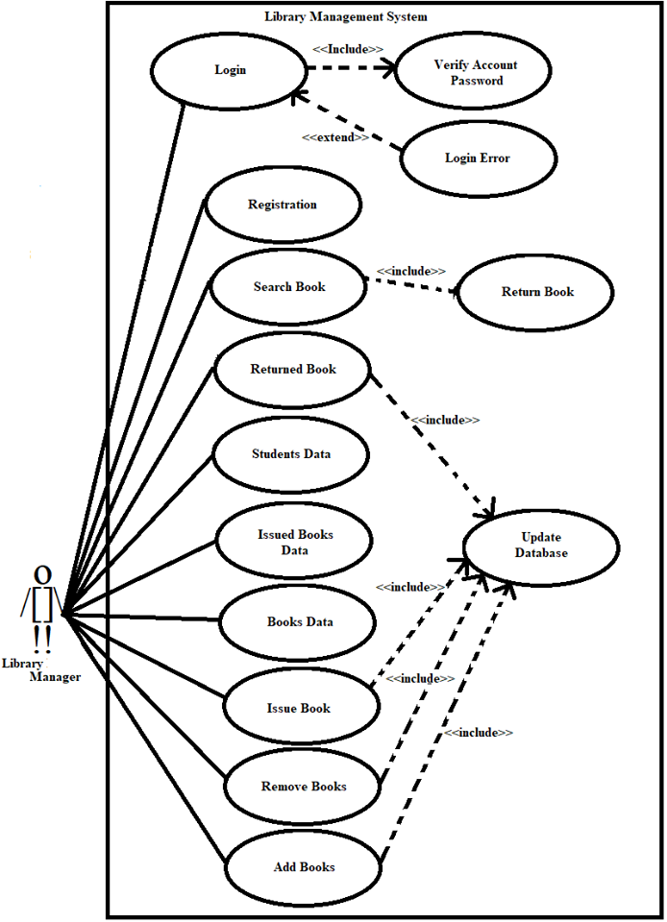

**Login**

-User name: String

-Password: String

-Login (): void

-Exit (): void

**Issue Book**

-Account No: String

-Student Name: String

-Department: String

-Year: String

-Contact No: String

-Book Name: String

-Shelf No: String

-Category: String

-Row No: String

-Date of Issue: String

-Date of Return: String

-Search Book (): void

-Search All Book (): void

-Search Account No (): void

-Issue Book (): void

**New Registration**

-Student Name: String

-Account No: String

-Department No: String

-Semester Year: String

-Contact No: String

-Register (): void

**Return Books**

-Account No: String

-Student Name: String

-Department: String

-Year: String

-Contact No: String

-Book Name: String

-Shelf No: String

-Category: String

-Row No: String

-Date of Issue: String

-Date of Return: String

-Search Book (): void

-Search All Book (): void

-Search Account No (): void

-Return Book (): void

**Driver Class**

+ Main (args): void

**Actions**

-Issue/Search Books: String

-Return Books: String

-Add Books: String

-Remove Books: String

-Issued Books Data: String

-Books Data: String

-Next Form (): void

**Student Data**

-Account No: String

-Search Student (): void

-Search All Students (): void

-Remove Student (): void

**Add Books**

-Book Name: String

-Category: String

-Shelf No: String

-Room No: String

-Quantity: String

-Available Quantity: String

-Add Books (): void

-Search Books (): void

**Driver Class**

+ Main (args): void

**Remove Books**

-Book Name: String

-Category: String

-Remove Book (): void

-Remove All Book (): void

-Search Book (): void

-Search All Books (): void

**Books Data**

-Book Name: String

-Category: String

-Search Book (): void

-Search All Books (): void

**Issued Books Data**

-Account No: String

-Search Book (): void

-Search All Books (): void

3.3.2 Database Structure

**Table 3-1: Librarian Login Table**

|  |  |  |  |
| --- | --- | --- | --- |
| **Column Name** | **Data Type** | **Null Value** | **Description** |
| User Name | Long Text | Not Null |  |
| Password | Long Text | Not Null |  |

**Table 3-2: Books Data Table**

|  |  |  |  |
| --- | --- | --- | --- |
| **Column Name** | **Data Type** | **Null Value** | **Description** |
| Book Name | Long Text |  |  |
| Category | Long Text |  |  |
| Shelf No | Short Text |  |  |
| Row No | Short Text |  |  |
| Quantity | Long Text |  |  |
| Available Quantity | Long Text |  |  |

**Table 3-3: Student Accounts Table**

|  |  |  |  |
| --- | --- | --- | --- |
| **Column Name** | **Data Type** | **Null Value** | **Description** |
| Student Name | Long Text |  |  |
| Account No | Long Text | Not Null | Primary Key |
| Department | Long Text |  |  |
| Semester / Year | Long Text |  |  |
| Contact No | Long Text |  |  |

**Table 3-4: Issue Book Data Table**

|  |  |  |  |
| --- | --- | --- | --- |
| **Column Name** | **Data Type** | **Null Value** | **Description** |
| Student Name | Long Text |  |  |
| Account No | Long Text | Not Null | Primary Key |
| Department | Long Text |  |  |
| Semester / Year | Long Text |  |  |
| Contact No | Long Text |  |  |
| Book Name | Long Text |  |  |
| Category | Long Text |  |  |
| Shelf No | Short Text |  |  |
| Row No | Short Text |  |  |
| Date Of Issue | Long Text |  |  |
| Date Of Return | Long Text |  |  |

3.4 Licensing Requirements

Library Management System will be available under an End User License Agreement (EULA).

4. References

[1] Anthony Cassels, *Information Centre Manager Fera*, Room 11G08, Sand Hutton, York, YO41 1LZ.

[2] [http://repository.sustech.edu/bitstream/handle/123456789/7384/chapter%203.pdf? sequence=6](http://repository.sustech.edu/bitstream/handle/123456789/7384/chapter%203.pdf?%20sequence=6)

[3] IEE STD 830-1998 Standard Recommended Practice For Software Requirement Specification.

[4] H.C. Tao. Software engineering, Beijing: economic science press, pp. 292-311, 2004.

[5] Rachel S. Smith, Senior Interface Designer, CSU Center for Distributed Learning.